**ONLINE AUCTION SYSTEM**

**A CAPSTONE PROJECT REPORT**

*Submitted in partial fulfillment of the*

*requirement for the award of the*

*Degree of*

**BACHELOR OF TECHNOLOGY**

**IN**

**COMPUTER SCIENCE AND ENGINEERING**

*by*

**ROHITH REDDY DIRISALA(19BCE7303)**

**HRUTHIK YADAV MADATI (19BCN7092)**

*Under the Guidance of*

**DR. AJAY KUMAR MALLICK**



SCHOOL OF COMPUTER SCIENCE AND ENGINEERING

VIT-AP UNIVERSITY

AMARAVATI- 522237

*DECEMBER 2022*

**CERTIFICATE**

This is to certify that the Capstone Project work titled “**ONLINE AUCTION SYSTEM**” that is being submitted by **Rohith Reddy Dirisala(19BCE7303)** & **Hruthik Yadav Madati(19BCN7092)**, is in partial fulfillment of the requirements for the award of Bachelor of Technology, is a record of bonafide work done under my guidance. The contents of this Project work, in full or in parts, have neither been taken from any other source nor have been submitted to any other Institute or University for award of any degree or diploma and the same is certified.

Guide

**The thesis is satisfactory / unsatisfactory**

**Internal Examiner External Examiner**

**Approved by**

**PROGRAM CHAIR DEAN**

B. Tech. CSE School Of Computer Science and Engineering

**TABLE OF CONTENTS**

|  |  |  |  |
| --- | --- | --- | --- |
| **S.No.** | **Chapter** | **Title** | **Page Number** |
| **1** |  | **List of Figures and Table** | **3** |
| **2.** | **1**  **1.1**  **1.2**  **1.3** | **Introduction**  **Motivation**  **Objectives**  **Novelty** | **4**  **4**  **5** |
| **3.** | **2**  **2.1**  **2.2**  **2.3** | **ONLINE AUCTION SYSTEM**  **Proposed System**  **Working methodology**  **Application** | **6**  **8**  **8** |
| **4.** | **3.1**  **3.2** | **Result Analysis**  **Conclusion and Future work** | **15**  **17** |
| **5.** | **4**  **4.1**  **4.2**  **4.3** | **Appendix**  **Poster**  **Source code**  **References** | **18**  **19**  **51** |

**List of Tables**

|  |  |  |
| --- | --- | --- |
| **Table.no** | **Title** | **Page.no** |
| **1** | **bidItems** | **13** |
| **2** | **userInfo** | **13** |
| **3** | **sellerInfo** | **14** |

**List of Figures**

|  |  |  |
| --- | --- | --- |
| **Sl.no** | **Title** | **Page.no** |
| **1** | **Use-case diagram** | **6** |
| **2** | **ER-diagram** | **7** |
| **3** | **Login page** | **9** |
| **4** | **User login page** | **10** |
| **5** | **Seller login page** | **11** |
| **6** | **Full Bid page** | **12** |
| **7** | **Successful bid** | **15** |
| **8** | **Failed bid** | **16** |

**CHAPTER 1**

**INTRODUCTION**

**1.1 MOTIVATION**

In our work an efficient system is presented which can facilitate easy bidding and listing of various items worldwide .Traditional Auction houses have been around for a very long time. But they have certain shortcomings such as the scope of the bidding which is mostly restricted to local population. So, we are building a website for the auctions to be available for larger section of people and can be completed effectively.

The system is designed to allow users to set up their products for auctions and bidders to register and bid for various products available for bidding. Since the items are put to bidding online, we cannot the verify the entities put by regular users online. Hence, we are considering to allow the items of enterprises only to be put on the website for bidding.[1] This ensures the quality of the products put on the website.

**1.2 OBJECTIVES**

The following are the objectives of this project:

* To design an efficient system which can automatically manage the listed items for bidding and help sellers from remote places to list their items online for bidding
* The Auction system is built to facilitate many users to concurrently bid on a certain item/service
* It simplifies the process of auction by handling all the transactions between the user and the seller using a robust web application system

**1.3 NOVELTY**

The primary distinction between a traditional auction and an online auction is convenience. In an online auction , a user can simply find any interesting items to bid on using the category as a parameter. It is very effective when compared to traditional auction sessions where items are revealed only during the session so the bidders cannot plan their bids beforehand. Most of the bids will be impulsive and irrational.

Another factor we could find contrasting is the cost of maintenance and the manpower involved behind it. Online Auction System totally nullifies the maintenance cost and manpower as there is no such entities involved in running an auction system except computing resources[5] and a few skilled programming personnel.

The difference can also be seen when we consider the diversity of the user-base . Generally in online auction systems , we can find users from various communities, places participating in the bidding process simultaneously . But in traditional auction houses , most of the users will be from the same locality or community.

**CHAPTER-2**

**ONLINE AUCTION SYSTEM**

**2.1 Proposed System**

The following block diagram (figure 1) shows the system architecture of this project.

Admin

Seller

Customer

**Figure 1 System Use-case Diagram of the system[7]**



**Figure 2 ER diagram of the proposed system [3]**

**2.2 Working Methodology**

The system has two sets of users

1. Users
2. Sellers

Depending on the type of users , various functionalities are embedded in the system[2]

**Users** have the majority of the functionality in the website since everything in the system is designed around the user accounts . One of the primary feature of the user account type is the Bidding functinality which enables the user accounts to bid on any item of their choice unless they have the required credits in their account. Some other features include viewing the seller of a particular bid , time remaining for the bid, current bid amount . The user can also view their information stored in the database[3].

**Sellers** have very limited functionality given that it is not intended for any bidding activites.It is just used for listing an item, viewing the listed items , viewing the current Bid amount , current Bidder . The sellers also could view their information stored on the database[3] using the view accountInfo option.

**2.3 Application:**

This section describes the software details of the system:

The overview of the web application could be divided into three components for our easy understanding

1. Frontend/Client side
2. Backend/Server side ( using linux-based Ec2 instances [5] )
3. Database (using mysql powered rds instance [6] )

**I. Frontend/Client side**

**Login page:**

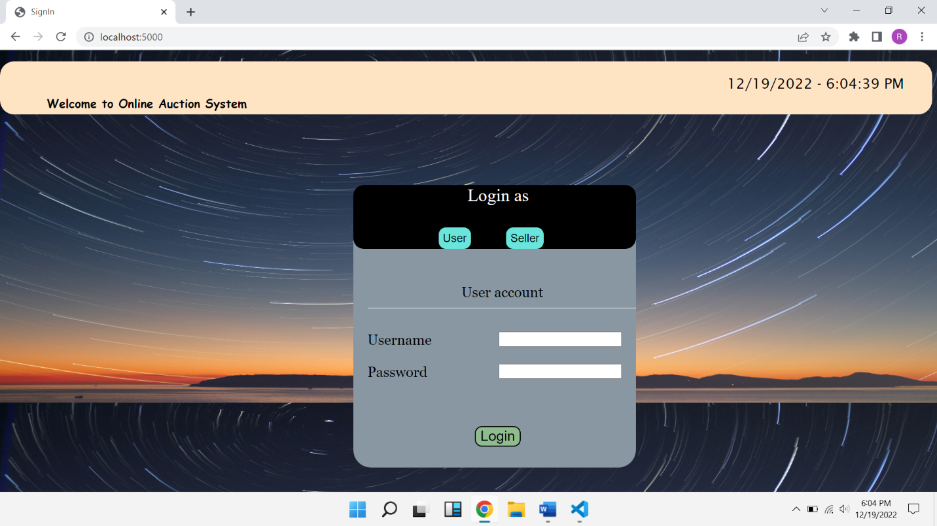

**Figure3: Index/Login page of the website (both user and seller) [1]**

* A **<span> element** is used to display the live time at the top right corner of the page using a javascript function which keeps on executing every 500 milliseconds to display the live time accurately.
* A form is created for two different types of account namely **user and seller** which has two **post** methods for each separate type.
* The two forms transistion without a page reload with the help of javascript display properties .

**User login Page:**

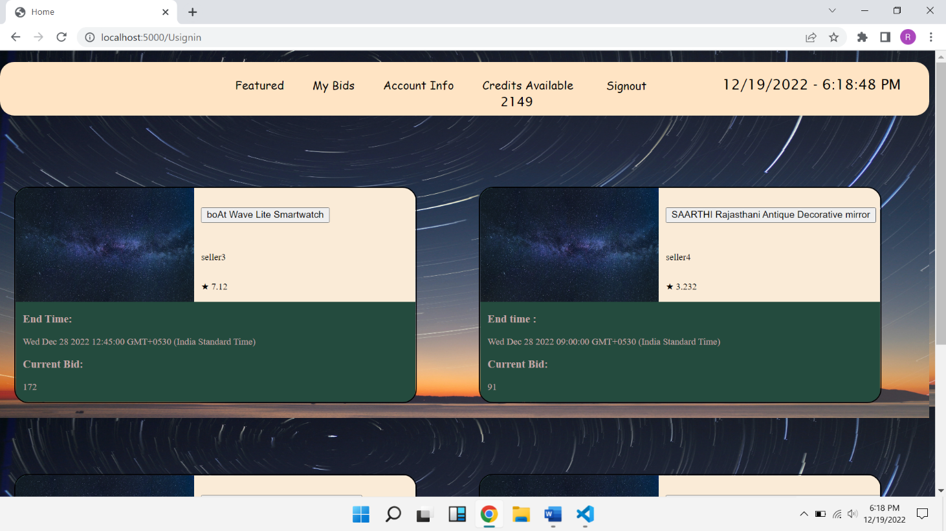

**Figure4: Home page of the user displaying various elements [1]**

* This is the **home page** for a User
* The **navigation bar[1]** consists of
  + - Featured
    - My Bids
    - Account Info
    - Credis Available to a user
    - Signout button
    - Live time element
* The navigation bar helps the user to navigate through various modules with ease without having to reload the page entirely
* Then the ongoing Bids are displayed using a <div> template [1] and styled using external css file

**Seller Login page:**

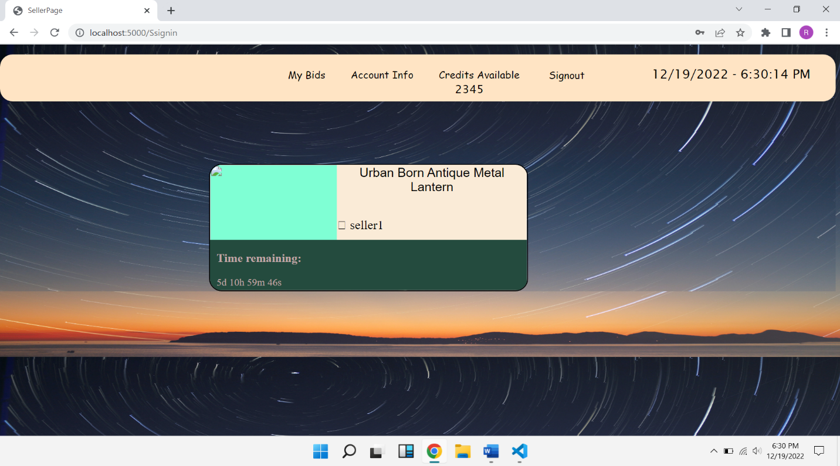

**Figure5: Home page of the seller displaying various elements [1]**

* Here the navigation bar consists of
* My Bids
* AccountInfo
* Credits Available
* Signout
* The Bids of the seller are display using a div element [1] to display the **Bid title, time remaining**

**Full Bid page:**

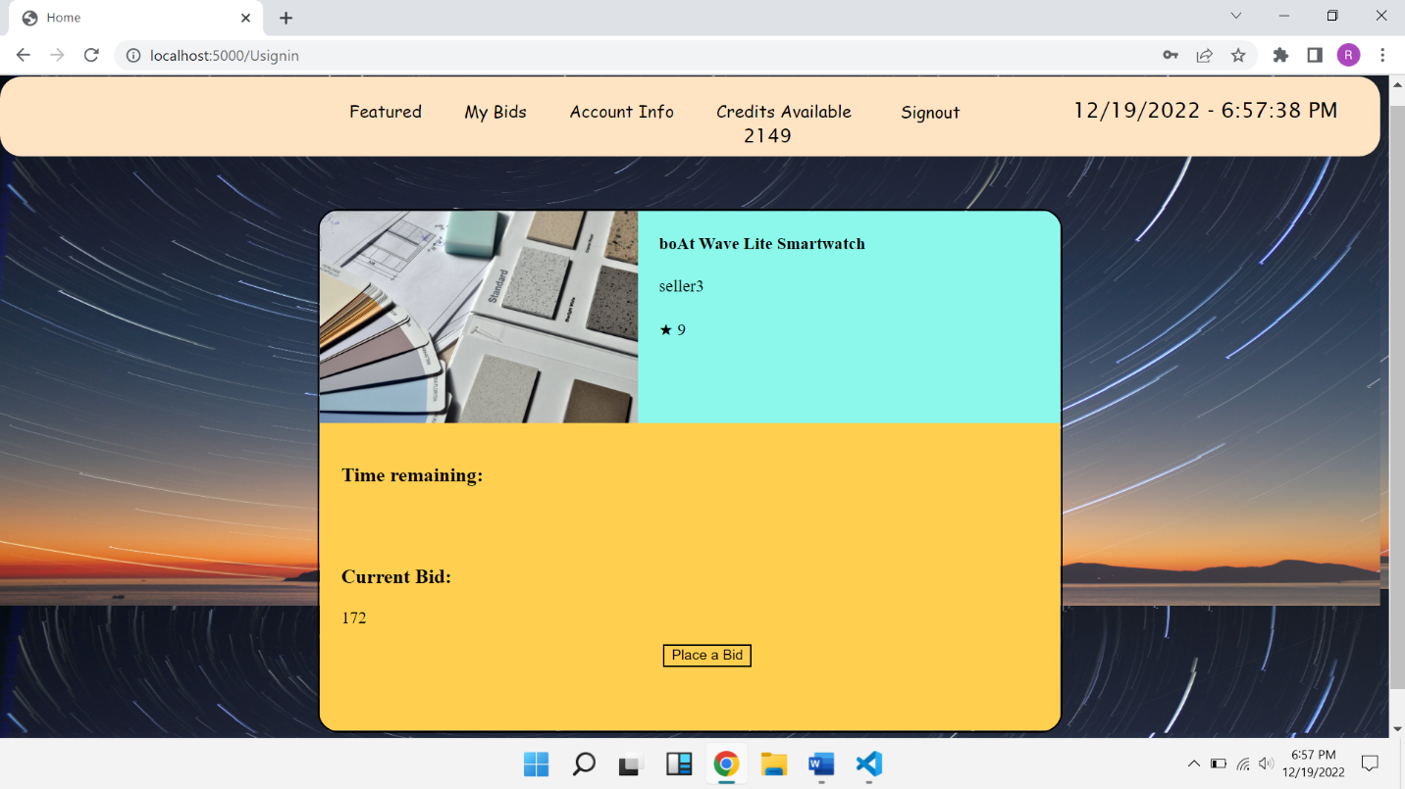

**Figure6: Full bid page which displays all the information of a bid [1]**

* The Full Bid page consists of a **<div>** element[1] which has
  + Image container for storing image
  + Title field
  + Time field
  + Bid field ,which is used to invoke functions related to Bidding

**Database:**

**Table1: mysql table consisting of details of all the items in bidding**

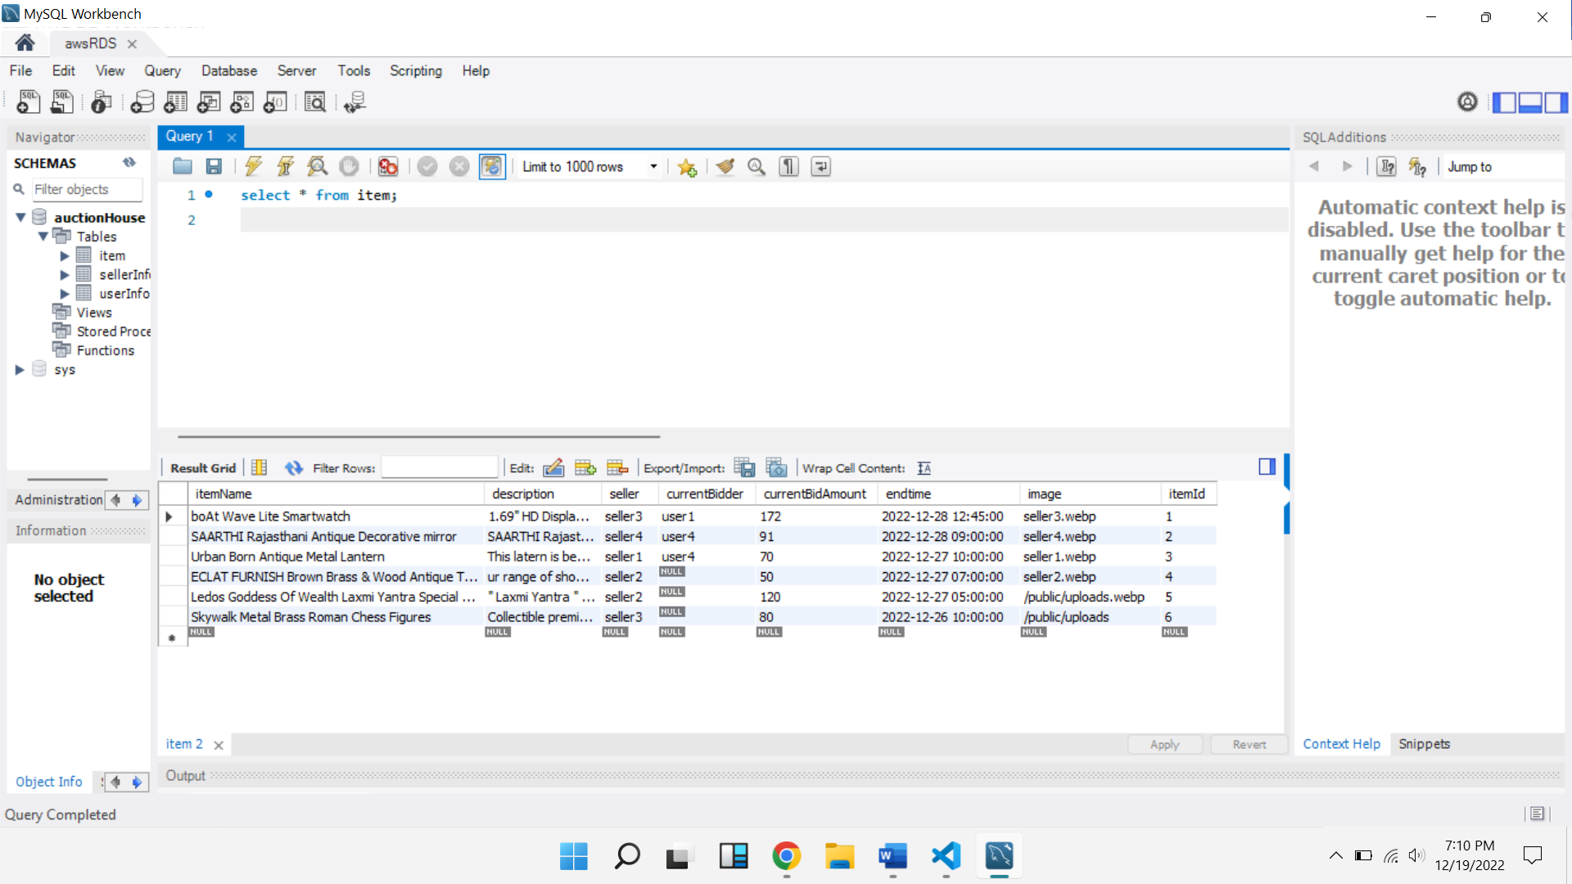

**Table2: mysql table consisting of all users and their information**

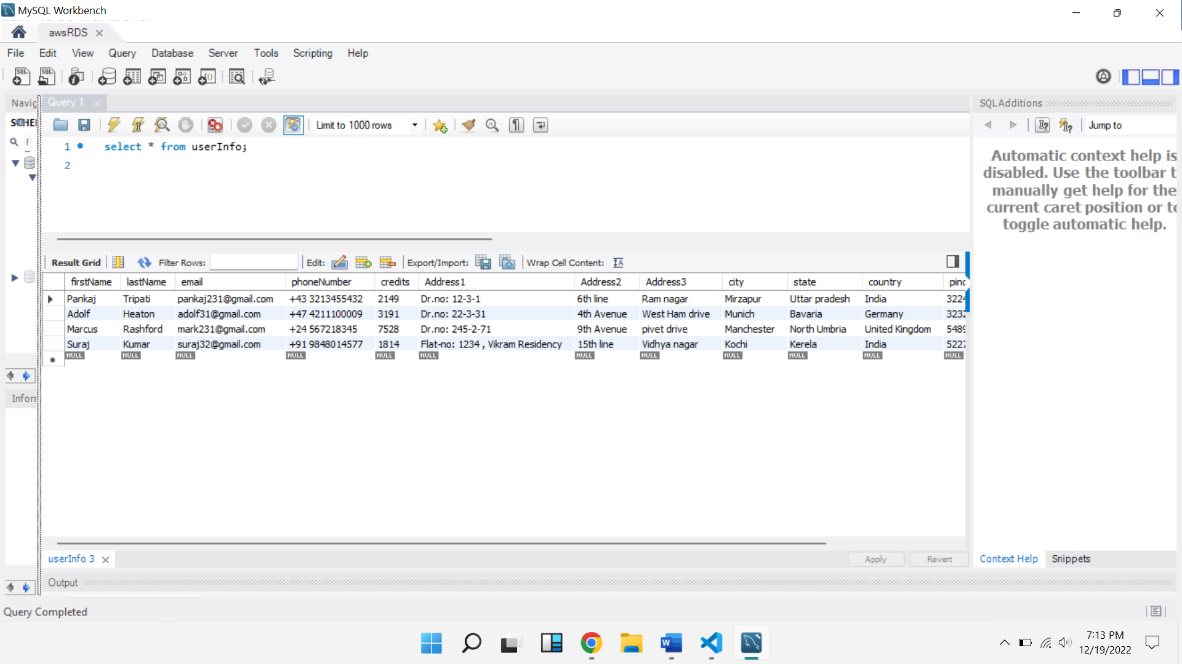

**Figure8**

**Table3: mysql table consisting of all sellers and their information**

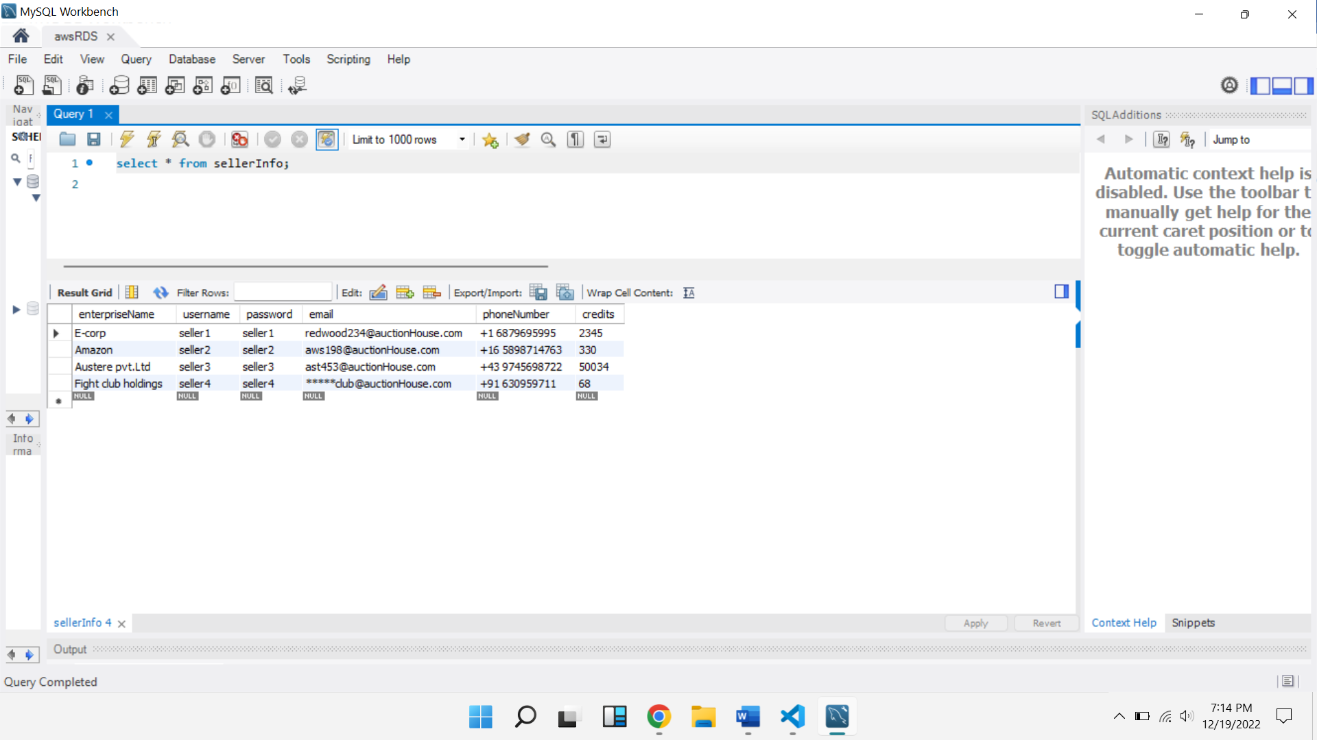

**Basic Routing used on Server side**

After referencing various techniques from reference material [1]] we created the following routes for navigation of the website using expressjs [4]

**App.post(‘/’) :** used to display index page on starting the server[4]

**App.post(‘/userSignIn’):** used to validate the data taken from the userlogin form

**App.post(‘/sellerSignin’):** used to validate the data taken from the seller login form

**App.post(‘/bidPlace’):** used to validate the user credits[4] and if successful bids an item in the favour of the user logged in

**App.post(‘/signOut’):** redirects the user back to login page/index page

**Chapter-3**

**3.1 Result Analysis**

**Bidding:**

The bidding process which is crucial to the functioning of the application is shown in the below figure.

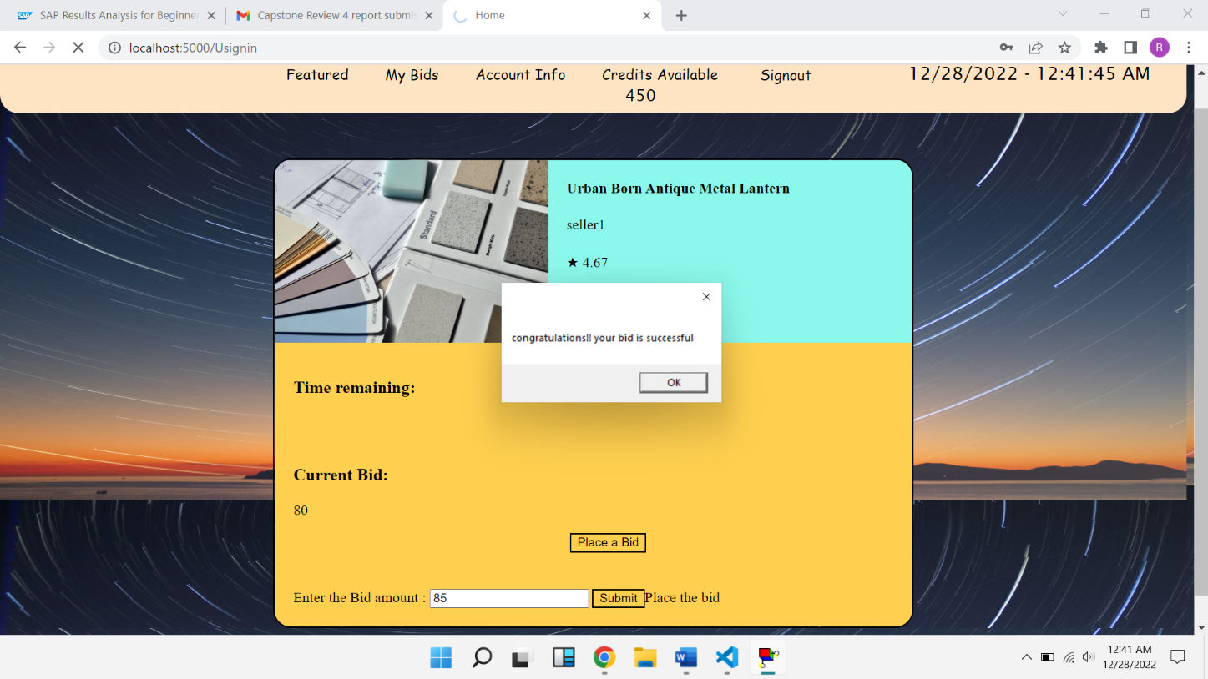

**Figure 7: Entering the correct bid amount for a particular bid item**

When the bid amount is entered , the data is sent to the server using post method [4] then the server checks if the bid amount entered is higher than the current bid and also if the user could afford the bid (i.e whether the user has the required no of credits in his account) . If the bid amount passes these two parameters , then the bid data is updated and the respective changes are also made in the database.

But when the given data doesn’t satisty any one of two conditions , then the bid is cancelled and a error message is shown to correct the bid amount.

**Figure 8: Entering the incorrect bid am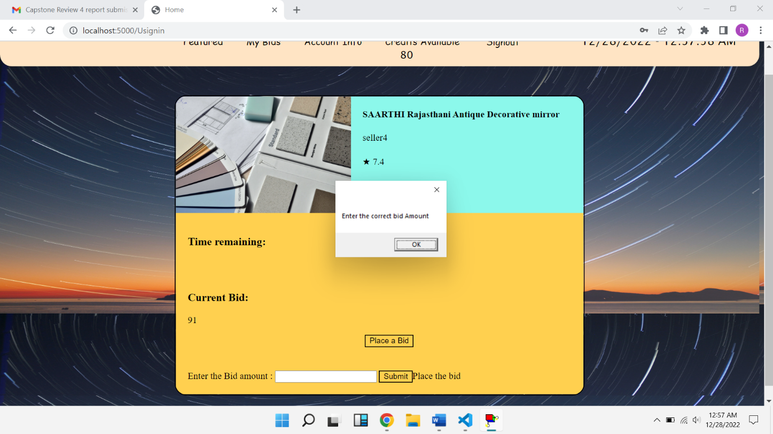ount for an item**

When the bidding time is over, the “current bid” amount will be reflected in the account of the seller and the respective changes will be made in the database [3]. Since the input is processed in the backend(Server) [4], the input validation[1] is much secured and reliable .

**3.2 Conclusion and Future Work**

Through the implementation of this project , we tried to replicate all the functions of an auction house through our web application[1]. Since all the businesses are trying to function virtually these past few years, this would be a perfect solution for auction houses to sustain their business even during critical times like pandemics etc. It also enables users irrespective of their location to bid on any item they want instantly. This could also become a huge advantage to the sellers as they get more bids coming in for their listed items when compared to bids in auction houses.

Although there is also so much room for improvement in this project as this could be used to take the whole auction house experience online. We could use some machine learning algorithms to find the user’s engagement levels with the application and find which type of items are users more intrested in . We could also introduce services instead of products from trusted retailers so that there would be a variety of entities for users to bid on.

**Chapter-4**

**Appendix**

**4.1 Poster:**

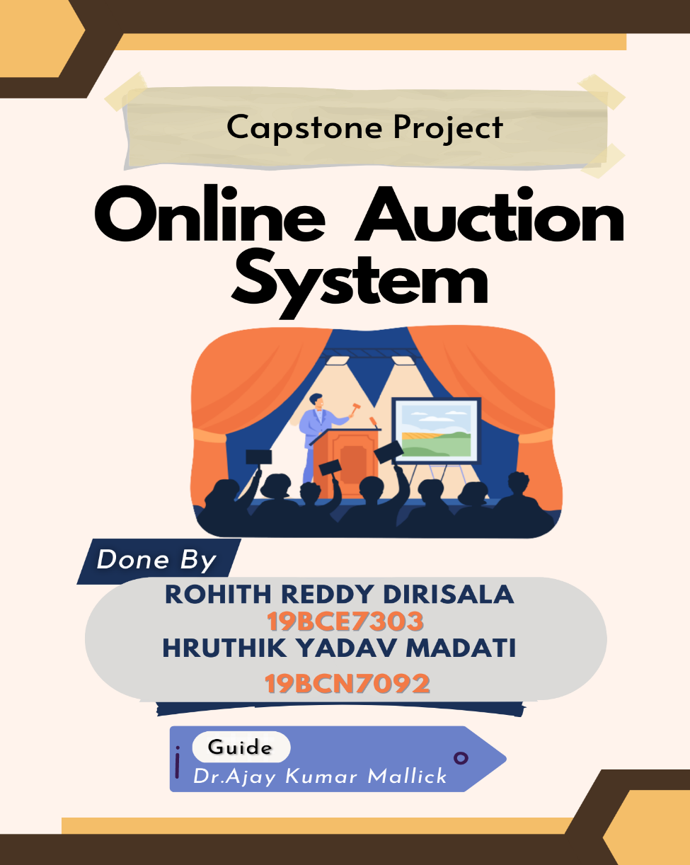

**4.2 Source code:**

**Index.js file:**

const { application, request } = require('express');

const mysql=require('mysql');

const express=require('express');

const ejs = require('ejs');

const multer=require('multer');

const app=express();

app.set('view engine', 'ejs');

app.set('views','./views');

app.use(express.static('public'));

app.use(express.json());

var bodyParser = require('body-parser');

const { render } = require('pug');

let alert=require('alert');

let window=require('window');

app.use(bodyParser.json());

app.use(bodyParser.urlencoded({extend:false}));

//database connection

const db = mysql.createConnection({

host : "auctiondatabase.c5xfieorp2bw.ap-south-1.rds.amazonaws.com" ,

user : "rohith26721",

password : "Rohith1290",

port : "3306",

database : "auctionHouse"

});

db.connect(function(err){

console.log("Connected!");

});

app.listen(5000);

//PAGE ROUTES....

let uname;

let sname;

let EnameSeller;

let itemId;

let path;

let iName;

let iDescription;

let iSeller;

let iImage;

let iTime;

let iName1;

let iSeller1;

let iTime1;

let iName2;

let iSeller2;

let iTime2;

let iName3;

let iSeller3;

let iTime3;

let iName4;

let iSeller4;

let iTime4;

let iAmount1;

let iAmount2;

let iAmount3;

let iAmount4;

let creditsUser;

let iUser1;

let iUser2;

let iUser3;

let iUser4;

let cBidname;

let cSeller;

let cEndTime;

app.get('/',function(req,res){

res.render("index.ejs");

});

// user signin route....

// variable to take in userlogin values at the time of login request

app.post('/Usignin',function(req,res){

uname=req.body.UserName;

var pword=(req.body.PassWord);

var firstnameUser;

var lastnameUser;

var emailUser;

var phonenumberUser;

var address1User;

var address2User;

var address3User;

var cityUser;

var stateUser;

var countryUser;

var pincodeUser;

var usernameUser;

var passwordUser;

db.query("select * from userInfo where username = ? ",[uname],function(err,results,fields){

firstnameUser=results[0].firstName;

lastnameUser=results[0].lastName;

emailUser=results[0].email;

phonenumberUser=(results[0].phoneNumber);

creditsUser=results[0].credits;

address1User=results[0].Address1;

address2User=results[0].Address2;

address3User=results[0].Address3;

cityUser=results[0].city;

stateUser=results[0].state;

countryUser=results[0].country;

pincodeUser=results[0].pincode;

creditsUser=results[0].credits;

});

db.query("select * from item",function(err,result,fields){

if(err)

console.log("value not updated");

iName1=result[0].itemName;

iSeller1=result[0].seller;

iTime1=result[0].endtime;

iUser1=result[0].currentBidder;

iAmount1=result[0].currentBidAmount;

iName2=result[1].itemName;

iSeller2=result[1].seller;

iTime2=result[1].endtime;

iUser2=result[1].currentBidder;

iAmount2=result[1].currentBidAmount;

iName3=result[2].itemName;

iSeller3=result[2].seller;

iUser3=result[2].currentBidder;

iTime3=result[2].endtime;

iAmount3=result[2].currentBidAmount;

iName4=result[3].itemName;

iSeller4=result[3].seller;

iUser4=result[3].currentBidder;

iTime4=result[3].endtime;

iAmount4=result[3].currentBidAmount;

});

db.query("select * from userInfo where username = ? and password = ?",[uname,pword], function(err, result, fields) {

if(err){

console.log("error evaded");

res.redirect('/');

}

if(result.length>0){

res.render("UserLogin.ejs",

{"firstname" : firstnameUser ,

"lastname" : lastnameUser,

"email" : emailUser,

"phonenumber" :phonenumberUser,

"credits" : creditsUser,

"address1" : address1User,

"address2" : address2User,

"address3" : address3User,

"city" : cityUser,

"state" : stateUser,

"country" : countryUser,

"pincode" : pincodeUser,

"username" : uname,

"password" : pword,

"credits" : creditsUser,

"name1":iName1,

"seller1":iSeller1,

"time1":iTime1,

"name2":iName2,

"seller2":iSeller2,

"time2":iTime2,

"name3":iName3,

"seller3":iSeller3,

"time3":iTime3,

"name4":iName4,

"seller4":iSeller4,

"time4":iTime4,

"amount1":iAmount1,

"amount2":iAmount2,

"amount3":iAmount3,

"amount4":iAmount4,

});

console.log("user logged in successfully");

}

else

res.sendStatus(404);

res.end();

});

});

// Seller signin route ...

app.post('/Ssignin',function(req,res){

sname=req.body.Sid;

let spword=(req.body.SPwd);

db.query("select * from sellerInfo where username = ? ",[sname],function(err,results,fields){

EnameSeller=results[0].enterpriseName;

emailSeller=results[0].email;

phonenumberSeller=(results[0].phoneNumber);

creditsSeller=results[0].credits;

});

db.query("select * from item where seller = ? ",[sname],function(err,result,fields){

iName=result[0].itemName;

iDescription=result[0].description;

iSeller=result[0].seller;

iImage=result[0].image;

iTime=result[0].endtime;

});

db.query("select * from sellerInfo where username = ? and password = ?",[sname,spword], function(err, result, fields) {

if(result.length>0){

res.render("sellerLogin.ejs",

{"enterpriseName" : EnameSeller ,

"email" : emailSeller,

"phonenumber" :phonenumberSeller,

"credits" : creditsSeller,

"username" : sname,

"password" : spword,

"itemName" :iName,

"description": iDescription,

"seller": iSeller,

"image" : iImage,

"time" : iTime

});

console.log("seller logged in successfully");

}

else

res.sendStatus(404);

});

});

app.post('/item1Bid',function(req,res){

let bid=req.body.item1BidAmount;

let prevUser;

if(bid>iAmount1&&creditsUser>=bid){

creditsUser=creditsUser-bid;

db.query("UPDATE userInfo SET credits = ? WHERE (username = ?);",[iAmount1,iUser1]);

db.query("UPDATE item SET currentBidder = ?, currentBidAmount = ? WHERE (itemId = '1');",[uname,bid]);

db.query("UPDATE userInfo SET credits = ? WHERE (username = ?);",[creditsUser,uname]);

alert("congratulations!! your bid is successful");

}

else{

alert("Enter the correct bid Amount");

res.redirect('/Usignin');

}

});

app.post('/item2Bid',function(req,res){

let bid=req.body.item2BidAmount;

if(bid>iAmount2&&creditsUser>=bid){

creditsUser=creditsUser-bid;

db.query("UPDATE userInfo SET credits = ? WHERE (username = ?);",[iAmount2,iUser2]);

db.query("UPDATE item SET currentBidder = ?, currentBidAmount = ? WHERE (itemId = '2');",[uname,bid]);

db.query("UPDATE userInfo SET credits = ? WHERE (username = ?);",[creditsUser,uname]);

alert("congratulations!! your bid is successful");

}

else{

alert("Enter the correct bid Amount");

}

});

app.post('/item3Bid',function(req,res){

let bid=req.body.item3BidAmount;

if(bid>iAmount3&&creditsUser>=bid){

creditsUser=creditsUser-bid;

db.query("UPDATE userInfo SET credits = ? WHERE (username = ?);",[iAmount3,iUser3]);

db.query("UPDATE item SET currentBidder = ?, currentBidAmount = ? WHERE (itemId = '3');",[uname,bid]);

db.query("UPDATE userInfo SET credits = ? WHERE (username = ?);",[creditsUser,uname]);

alert("congratulations!! your bid is successful");

}

else{

alert("Enter the correct bid Amount");

}

})

app.post('/item4Bid',function(req,res){

let bid=req.body.item4BidAmount;

if(bid>iAmount4&&creditsUser>=bid){

creditsUser=creditsUser-bid;

db.query("UPDATE userInfo SET credits = ? WHERE (username = ?);",[iAmount4,iUser4]);

db.query("UPDATE item SET currentBidder = ?, currentBidAmount = ? WHERE (itemId = '4');",[uname,bid]);

db.query("UPDATE userInfo SET credits = ? WHERE (username = ?);",[creditsUser,uname]);

alert("congratulations!! your bid is successful");

}

else{

alert("Enter the correct bid Amount");

}

})

app.get('/signout',function(req,res){

res.render("index.ejs");

})

app.post('/addBid',function(req,res){

var newBidName=req.body.newBidName;

var newBidId=req.body.newBidId;

var newBidDescription=req.body.newBidDescription;

const newBidT=req.body.newBidTime;

var newBidAmount=req.body.newBidAmount;

var imageLocation='/public/uploads';

db.query("insert into item values(?,?,?,'NULL','0',?,?,?);",[newBidName,newBidDescription,sname,newBidT,imageLocation,newBidId],function(err,results,fields){

});

});

**View files:**

**Index.ejs:**

<!DOCTYPE html>

<html>

<head>

<title>

SignIn

</title>

<meta charset="utf-8" http-equiv="X-UA-compatible" content="IE-edge" name="viewport" content="width=device-width,initial-scale=1.0">

<link rel="stylesheet" href="styles.css" >

<script src="myscript.js"></script>

<script type="text/javascript">

window.history.forward();

function noBack() {

window.history.forward();

}

</script>

</head>

<body><div class="nav">

<ul class="navigation_menu" style="display:run-in";>

<li style="float:right ;margin-left:40px;"><span id="time"></span></li>

<li style="padding-bottom:20px;margin-right:50%;font-family:cursive;font-size: 20px;float:center;"><h5 >Welcome to Online Auction System</h5></li>

</ul>

</div>

<div class="body">

<div class="form1">

<div id="loginLabel">

<label style="margin-left:10px;">Login as </label><br><br>

<button class="LoginButton" onclick="LoginForm()">User</button><button class="LoginButton" onclick="SignUpForm()">Seller</button></div>

<div class="form-box">

<form id="loginForm" action="/Usignin" method="post">

<label style="margin-left:35%;">User account</label><br><hr><br>

<label>Username </label><input id="Uid" class="inputFields" type="text" required="required" name="UserName"><br><br>

<label>Password </label><input id="UPwd" class="inputFields" type="password" required="required" name="PassWord"><br><br><br>

<input target="blank" type="submit" value="Login" id='ULoginSubmit' class="submitButton" style="margin-bottom:30px ;">

</form>

<form id="signup" style="display:none" action="/Ssignin" method="post">

<label style="margin-left:35%;">Seller account</label><br><hr><br>

<label>Username </label><input id="Sid" name="Sid" class="inputFields" type="text" required="required" ><br><br>

<label>Password </label><input id="SPwd" name="SPwd" class="inputFields" type="password" required="required"><br><br><br>

<input type="submit" value="Login" id='SLoginSubmit' class="submitButton" style="margin-bottom:30px ;">

</form>

</div>

</div>

</div>

</body>

</html>

**userLogin.ejs:**

<!DOCTYPE html>

<html>

<head>

<meta charset="utf-8" http-equiv="X-UA-compatible" content="IE-edge" name="viewport" content="width=device-width,initial-scale=1.0">

<link rel="stylesheet" href="styles.css">

<script src="myscript.js"></script>

<script type="text/javascript" >

function preventBack()

{

window.history.forward();

}

setTimeout("preventBack()", 0);

window.onunload=function(){null};

</script>

<title>

Home

</title>

</head>

<body>

<div class="nav">

<ul class="navigation_menu">

<li style="float:right;"><span id="time"></span></li>

<li style="margin-right:100px"><form action="/signout" method="get"><input type="submit" value="Signout" style="background-color:rgb(177, 171, 171);

border:none;background-color:bisque; cursor:pointer;font-family:cursive;font-size:medium;">

</form></li>

<li id="credits_info"><button class="b1" id="creditsInfo" >Credits Available</button><br>&nbsp &nbsp <span style="font-size:18px;" id="creditsAvailable" style="display:none;"><%=credits %></span></li>

<li id="account_info"><button class="b1" onclick="AcInfoDisplay()">Account Info</button></li>

<li id="bidsMenu"><button class="b1" onclick="BidsDisplay()">My Bids</button></li>

<li id="featuredBids"><button class="b1" onclick="featuredBidsDisplay()">Featured</button></li>

</ul>

</div>

<div id="featuredbids" >

<div class="area">

<div class="bidImageContainer">

<img class="image" src="backgroundImage1.jpg">

</div>

<div class="bidTitleContainer">

<div class="ProductName" style="margin:10px;"><h4><Button onclick="FullDisplay1()"><%=name1%></Button></h4></div>

<div class="SellerName" style="margin:10px;"> <%=seller1%></div>

<div class="Rating" style="margin:10px;">&#9733; 7.12</div>

</div>

<div class="bidVariablesContainer">

<div class="TimerContainer">

<h3>End Time: </h3><p><%=time1%></p>

</div>

<div class="BidAmountContainer">

<h3>Current Bid: </h3><p><%=amount1%></p>

</div>

</div>

</div>

<div class="area">

<div class="bidImageContainer">

<img class="image" src="backgroundImage1.jpg">

</div>

<div class="bidTitleContainer">

<div class="ProductName" style="margin:10px;"><h4><Button onclick="FullDisplay2()"><%=name2%></Button></h4></div>

<div class="SellerName" style="margin:10px;"> <%=seller2%></div>

<div class="Rating" style="margin:10px;">&#9733; 3.232</div>

</div>

<div class="bidVariablesContainer">

<div class="TimerContainer">

<h3>End time : </h3><p><%=time2%></p>

</div>

<div class="BidAmountContainer">

<h3>Current Bid: </h3><p><%=amount2%></p>

</div>

</div>

</div>

<div class="area">

<div class="bidImageContainer">

<img class="image" src="backgroundImage1.jpg">

</div>

<div class="bidTitleContainer">

<div class="ProductName" style="margin:10px;"><h4><Button onclick="FullDisplay3()"><%=name3%>></Button></h4></div>

<div class="SellerName" style="margin:10px;"><%=seller3%></div>

<div class="Rating" style="margin:10px;">&#9733; 9.9</div>

</div>

<div class="bidVariablesContainer">

<div class="TimerContainer">

<h3>end Time: </h3><p><%=time3%></p>

</div>

<div class="BidAmountContainer">

<h3>Current Bid: </h3><p><%=amount3%></p>

</div>

</div>

</div>

<div class="area">

<div class="bidImageContainer">

<img class="image" src="backgroundImage1.jpg">

</div>

<div class="bidTitleContainer">

<div class="ProductName" style="margin:10px;"><h4><Button onclick="FullDisplay4()"><%=name4%></Button></h4></div>

<div class="SellerName" style="margin:10px;"> <%=seller4%></div>

<div class="Rating" style="margin:10px;">&#9733; 7.12</div>

</div>

<div class="bidVariablesContainer">

<div class="TimerContainer">

<h3>end Time : </h3><p><%=time4%></p>

</div>

<div class="BidAmountContainer">

<h3>Current Bid: </h3><p><%=amount4%></p>

</div>

</div>

</div>

</div>

<div id="CurrentBids" >

<div class="area">

<div class="bidImageContainer">

<img class="image" src="https://images.pexels.com/photos/159045/the-interior-of-the-repair-interior-design-159045.jpeg?auto=compress&cs=tinysrgb&w=1260&h=750&dpr=2">

</div>

<div class="bidTitleContainer">

<div class="ProductName"><button style="border:none; background:none;" >Urban Born Antique Metal Lantern</button></div>

<div class="SellerName">&#xf007;seller1 </div>

</div>

<div class="bidVariablesContainer"><div class="TimerContainer">

<h3>End time </h3><p>2022-12-27 10:00:00</p>

</div>

</div>

</div>

</div>

<div id="BidDetails1">

<div class="FullImageContainer">

<img class="FullImage" src="https://images.pexels.com/photos/159045/the-interior-of-the-repair-interior-design-159045.jpeg?auto=compress&cs=tinysrgb&w=1260&h=750&dpr=2">

</div>

<div class="FullTitleContainer">

<div class="ProductName" style="margin:20px;"><h4><%=name1%></button></h4></div>

<div class="SellerName" style="margin:20px;"><%=seller1%></div>

<div class="Rating" style="margin:20px;">&#9733; 9</div>

</div>

<div class="FullVariablesContainer">

<div class="TimerContainer">

<h3>Time remaining: </h3><p><span id="days1"></span><span id="hours1"></span><span id ="minutes1"></span><span id ="seconds1"></span></p>

</div><br><br>

<div class="BidAmountContainer">

<h3>Current Bid: </h3><p><%=amount1%></p>

</div>

<div class="BidButton" style="margin-left:40%;margin-bottom:40px">

<button style= "background:none;" onclick="PlaceBid()" id="disableButton1">Place a Bid</button>

</div>

<div id="Placebid" style="display:none">

<form action="/item1Bid" method="post"><label>Enter the Bid amount : </label><input name="item1BidAmount"type="number" required="required">

<input style="background:none" type="submit">Place the bid</button></form>

</div>

</div>

</div>

<div id="BidDetails2">

<div class="FullImageContainer">

<img class="FullImage" src="https://images.pexels.com/photos/159045/the-interior-of-the-repair-interior-design-159045.jpeg?auto=compress&cs=tinysrgb&w=1260&h=750&dpr=2">

</div>

<div class="FullTitleContainer">

<div class="ProductName" style="margin:20px;"><h4><%=name2%></button></h4></div>

<div class="SellerName" style="margin:20px;"><%=seller2%></div>

<div class="Rating" style="margin:20px;">&#9733; 7.4</div>

</div>

<div class="FullVariablesContainer">

<div class="TimerContainer">

<h3>Time remaining: </h3><p><span id="days2"></span><span id="hours2"></span><span id ="minutes2"></span><span id ="seconds2"></span></p>

</div><br><br>

<div class="BidAmountContainer">

<h3>Current Bid: </h3><p><%=amount2%></p>

</div>

<div class="BidButton" style="margin-left:40%;margin-bottom:40px">

<button style= "background:none;" onclick="PlaceBid2()" id="disableButton1">Place a Bid</button>

</div>

<div id="Placebid2" style="display:none">

<form action="/item2Bid" method="post"><label>Enter the Bid amount : </label><input name="item2BidAmount"type="number" required="required">

<input style="background:none" type="submit">Place the bid</button></form>

</div>

</div>

</div>

<div id="BidDetails3">

<div class="FullImageContainer">

<img class="FullImage" src="https://images.pexels.com/photos/159045/the-interior-of-the-repair-interior-design-159045.jpeg?auto=compress&cs=tinysrgb&w=1260&h=750&dpr=2">

</div>

<div class="FullTitleContainer">

<div class="ProductName" style="margin:20px;"><h4><%=name3%></button></h4></div>

<div class="SellerName" style="margin:20px;"><%=seller3%></div>

<div class="Rating" style="margin:20px;">&#9733; 4.67</div>

</div>

<div class="FullVariablesContainer">

<div class="TimerContainer">

<h3>Time remaining: </h3><p><span id="days3"></span><span id="hours3"></span><span id ="minutes3"></span><span id ="seconds3"></span></p>

</div><br><br>

<div class="BidAmountContainer">

<h3>Current Bid: </h3><p><%=amount3%></p>

</div>

<div class="BidButton" style="margin-left:40%;margin-bottom:40px">

<button style= "background:none;" onclick="PlaceBid3()" id="disableButton1">Place a Bid</button>

</div>

<div id="Placebid3" style="display:none">

<form action="/item3Bid" method="post"><label>Enter the Bid amount : </label><input name="item3BidAmount"type="number" required="required">

<input style="background:none" type="submit">Place the bid</button></form>

</div>

</div>

</div>

<div id="BidDetails4">

<div class="FullImageContainer">

<img class="FullImage" src="https://images.pexels.com/photos/159045/the-interior-of-the-repair-interior-design-159045.jpeg?auto=compress&cs=tinysrgb&w=1260&h=750&dpr=2">

</div>

<div class="FullTitleContainer">

<div class="ProductName" style="margin:20px;"><h4><%=name4%></button></h4></div>

<div class="SellerName" style="margin:20px;"><%=seller4%></div>

<div class="Rating" style="margin:20px;">&#9733; 3.19</div>

</div>

<div class="FullVariablesContainer">

<div class="TimerContainer">

<h3>Time remaining: </h3><p><span id="days4"></span><span id="hours4"></span><span id ="minutes4"></span><span id ="seconds4"></span></p>

</div><br><br>

<div class="BidAmountContainer">

<h3>Current Bid: </h3><p><%=amount4%></p>

</div>

<div class="BidButton" style="margin-left:40%;margin-bottom:40px">

<button style= "background:none;" onclick="PlaceBid4()" id="disableButton1">Place a Bid</button>

</div>

<div id="Placebid4" style="display:none">

<form action="/item4Bid" method="post"><label>Enter the Bid amount : </label><input name="item4BidAmount"type="number" required="required">

<input style="background:none" type="submit">Place the bid</button></form>

</div>

</div>

</div>

<div class="accountInfo">

<table id="ACinfo" style="display:none">

<tr>

<td class="c1">Username</td>

<td class="c2"><%= username %></td>

</tr>

<tr>

<td class="c1">Password</td>

<td class="c2"><%= password %></td>

</tr>

<tr>

<td class="c1">First Name</td>

<td class="c2"><%= firstname %></td>

</tr>

<tr>

<td class="c1">Last-Name</td>

<td class="c2"><%= lastname %></td>

</tr>

<tr>

<td class="c1">E-mail </td>

<td class="c2"><%= email %></td>

</tr>

<tr>

<td class="c1">Address </td>

<td></td>

</tr>

<tr>

<td class="c1">Line1</td>

<td class="c2"><%= address1 %></td>

</tr>

<tr>

<td class="c1">Line2</td>

<td class="c2"><%= address2 %></td>

</tr>

<tr>

<td class="c1">Line3</td>

<td class="c2"><%= address3 %></td>

</tr>

<tr>

<td class="c1">City</td>

<td class="c2"><%= city %></td>

</tr>

<tr>

<td class="c1">State/UT</td>

<td class="c2"><%= state %></td>

</tr>

<tr>

<td class="c1">Country</td>

<td class="c2"><%= country %></td>

</tr>

<tr>

<td class="c1">Pincode</td>

<td class="c2"><%= pincode %></td>

</tr>

<tr>

<td class="c1">Phone number</td>

<td class="c2"><%= phonenumber %></td>

</tr>

</table>

</div>

</body>

</html>

**sellerLogin.ejs:**

<!DOCTYPE html>

<html>

<head>

<title>SellerPage</title>

<link rel="stylesheet" href="styles1.css">

<script src="myscript.js"></script>

<script>

let countDownDate=new Date('2022-12-25');

var myfunc = setInterval(function() {

var now = new Date().getTime();

var timeleft = countDownDate - now;

// Calculating the days, hours, minutes and seconds left

var days = Math.floor(timeleft / (1000 * 60 * 60 * 24));

var hours = Math.floor((timeleft % (1000 * 60 * 60 * 24)) / (1000 * 60 * 60));

var minutes = Math.floor((timeleft % (1000 * 60 * 60)) / (1000 * 60));

var seconds = Math.floor((timeleft % (1000 * 60)) / 1000);

// Result is output to the specific element

document.getElementById("daysM").innerHTML = days + "d "

document.getElementById("hoursM").innerHTML = hours + "h "

document.getElementById("minutesM").innerHTML = minutes + "m "

document.getElementById("secondsM").innerHTML = seconds + "s "

// Display the message when countdown is over

if (timeleft < 0) {

clearInterval(myfunc);

document.getElementById("daysM").innerHTML = ""

document.getElementById("hoursM").innerHTML = ""

document.getElementById("minutesM").innerHTML = ""

document.getElementById("secondsM").innerHTML = ""

document.getElementById("end").innerHTML = "TIME UP!!";

}

},500);

</script>

</head>

<body>

<div class="nav">

<ul class="navigation_menu">

<li style="float:right;"><span id="time"></span></li>

<li style="margin-right:100px"><form action="/signout" method="get"><input type="submit" value="Signout" style="background-color:rgb(177, 171, 171);

border:none;background-color:bisque; cursor:pointer;font-family:cursive;font-size:medium;">

</form></li>

<li id="credits_info"><button class="b1" id="creditsInfo" >Credits Available</button><br>&nbsp &nbsp <span style="font-size:18px;" id="creditsAvailable" style="display:none;"><%= credits %></span></li>

<li id="account_info"><button class="b1" onclick="ScInfoDisplay()">Account Info</button></li>

<li id="BidAdd" style="display:none"><button class="b1" onclick="AddingBid()"> Add New Item</button></li>

<li id="bidsMenu"><button class="b1" onclick="sellerCurrentBidsDisplay()">My Bids</button></li>

</ul>

</div>

<div id="sellerCurrentBids" >

<div class="area">

<div class="bidImageContainer">

<image class="image" typ="image/jpeg" src="seller4.jpg">

</div>

<div class="bidTitleContainer">

<div class="ProductName"><button style="border:none; background:none; font-size:20px;" ><%= itemName %></button></div><br><br>

<div class="SellerName" style="font-size:20px">&#xf007; <%= seller %></div>

</div>

<div class="bidVariablesContainer"><div class="TimerContainer">

<h3>Time remaining: </h3><p><span id="daysM"></span><span id="hoursM"></span>

<span id="minutesM"></span> <span id="secondsM"></span> <span id="end"></span><span id="gettime" ></span></p>

</div>

<div class="BidAmountContainer">

<h3>Current Bid: </h3><p>&#8377 99393</p>

</div></div>

</div>

</div>

<div id="bidAddMenu" style="display:none;">

<h3 style="text-align:center;margin-bottom:40px;">Enter the Item Details</h3>

<form id="bidAddForm" action="/addBid" method="post" enctype="multipart/form-data" >

<label>Name</label><input name="newBidName" class="inputFields" type="text" required="required"><br><br><br>

<label>Bid Id</label><input name="newBidId" class="inputFields" type="text" required="required"><br><br><br>

<label>Product Description</label><input id="newBidDescription" name="newBidDescription" class="inputFields" type="text" ><br><br><hr>

<label>Bid Starting Amount</label><input id="newBidStartingAmount" name="newBidAmount" class="inputFields" type="number" required="required"><br><br><hr>

<label> End Time</label><input id="newBidEndTime" class="inputFields" name="newBidTime" type="datetime-local" required="required"><br><br><hr>

<label>Image</label><input id="newBimage" name="newimage" class="inputFields" type="file" style="margin-right:10px"><br><br><br>

<input type="submit" value="List the Item" id="ItemList" class="submitButton" style="margin-left:35%;">

</form>

</div>

<div id="SellerAccountInfo" style="display:none;" >

<table id="SCinfo">

<tr>

<td class="c1">Username</td>

<td class="c2"><%= username %></td>

</tr>

<tr>

<td class="c1">Password</td>

<td class="c2"><%= password %></td>

</tr>

<tr>

<td class="c1">Enterprise-Name</td>

<td class="c2"><%= enterpriseName %></td>

</tr>

<tr>

<td class="c1">Business E-mail </td>

<td class="c2"><%= email %></td>

</tr>

<tr>

<td class="c1">Telephone number</td>

<td class="c2"><%= phonenumber %></td>

</tr>

</table>

</div>

</body>

</html>

**CSS file:**

**Styles.css:**

body,html{

background-image:url('sky.jpg');

font-family:'cursive';

margin-top:0;

margin-left:0;

background-size:1500px 500px;

}

.body{

position:absolute;

height: 500px;

}

button:hover{

cursor:pointer;

}

/*navigation menu*/

.nav{

padding-top:0;

margin-top:0;

width:100%;

height:75px;

background-color: bisque;

position:static;

border-radius:20px;

}

.navigation_menu li{

display:inline;

text-decoration:none;

width:auto;

list-style:none;

float:right;

font-size:20px;

float:right;

padding:0px;

margin-top:20px;

margin-right:40px;

font-family:'Lucida Sans', 'Lucida Sans Regular', 'Lucida Grande', 'Lucida Sans Unicode', Geneva, Verdana, sans-serif;

}

.navigation_menu li button{

font-size: medium;

font-family:cursive;

width:auto;

height:100%;

border:none;

background-color:bisque ;

padding:0;

}

.b1:hover{

background-color:rgb(177, 171, 171);

cursor:pointer;

}

/*Signin page*/

#time{

font-weight:400;

font-size:20px;

}

#time:hover{

background-color:none;

}

.LoginButton{

text-decoration: none;

background-color: rgb(105, 229, 220);

font-size:medium;

margin-left:20px;

margin-right:30px;

cursor: pointer;

height:30px;

border:none;

border-radius:10px;

}

#loginLabel{

text-align: center;

margin-top: 0;

margin-bottom: 50px;

background-color:black;

color:white;

border-radius: 15px;

font-size: 25px;

}

.form1{

width:400px;

font-size:20px;

margin-left:500px;

margin-top: 100px;

background-color:rgb(136, 151, 162);

border-radius: 25px;

}

.form-box{

font-family: Georgia, 'Times New Roman', Times, serif;

margin-left:20px;

}

.submitButton{

cursor:pointer;

border-radius:10px;

margin-left: 40%;

font-size: 20px;

margin-top: 20px;

background-color: darkseagreen;

}

.inputFields{

margin-left:20px;

margin-right:20px;

float:right;

}

/* Featured Bids styling here */

#featuredbids{

display:grid;

margin-left:0px;

grid-template:

'p q'

'r s';

}

.area{

margin-left:20px;

margin-right:10px;

width:560px;

font-size:small;

height:300px;

margin-top:100px;

border:2px solid black;

border-radius:20px;

overflow:hidden;

display:grid;

grid-template-areas: 'a b b'

'c c c';

}

.bidImageContainer{

grid-area:a;

background-color:aquamarine;

height:160px;

width:250px;

margin:0;

padding:0;

overflow:hidden;

}

.image{

height:160px;

width:250px;

}

.bidTitleContainer{

grid-area:b;

background-color:antiquewhite;

width:340px;

height:160px;

margin:0;

padding:0;

}

.bidVariablesContainer{

padding-left:10px;

grid-area:c;

color:rgb(194, 168, 168);

background-color: rgb(36, 75, 62);

height:auto;

}

.bidTitleContainer{

display:grid;

grid-template-areas:

'g'

'h';

}

.ProductName{

grid-area:g;

margin:10px;

}

.SellerName{

grid-area:h;

margin:10px;

}

/*Current bids menu here*/

#CurrentBids{

display:none;

}

.Currentarea{

margin-left:20px;

margin-right:10px;

width:90%;

margin-top:100px;

margin-left:50px;

border:2px solid black;

border-radius:20px;

overflow:hidden;

}

/*Bid Details page*/

#BidDetails1{

display:none;

margin-top:50px;

margin-left:300px;

margin-right:300px;

padding:0;

grid-template:

'm n'

'o o';

border-radius:20px;

border:2px solid black;

overflow:hidden;

}

#BidDetails2{

display:none;

margin-top:50px;

margin-left:300px;

margin-right:300px;

padding:0;

grid-template:

'm n'

'o o';

border-radius:20px;

border:2px solid black;

overflow:hidden;

}

#BidDetails3{

display:none;

margin-top:50px;

margin-left:300px;

margin-right:300px;

padding:0;

grid-template:

'm n'

'o o';

border-radius:20px;

border:2px solid black;

overflow:hidden;

}

#BidDetails4{

display:none;

margin-top:50px;

margin-left:300px;

margin-right:300px;

padding:0;

grid-template:

'm n'

'o o';

border-radius:20px;

border:2px solid black;

overflow:hidden;

}

.FullImageContainer{

grid-area:m;

background-color: blue;

width:300px;

height:200px;

margin:0px;

}

.FullImage{

width:300px;

height:200px;

}

.FullTitleContainer{

grid-area:n;

margin-left:0px;

background-color: rgb(140, 248, 235);

margin:0px;

width:500px;

}

.FullVariablesContainer{

grid-area:o;

float:left;

background-color: rgb(255, 208, 79);

padding:20px;

}

.accountInfo{

margin-top: 40px;

margin-left: 35%;

}

#ACinfo{

width:70%;

height:500px;

}

#ACinfo td{

font-size:20px;

margin:10px;

padding:10px;

}

.c1{

background-color: grey;

color:beige

}

.c2{

background-color: white;

}

/* Bid Add menu*/

#bidAddMenu{

background-color:antiquewhite;

display:block;

margin-left:30%;

margin-right:30%;

border-radius:20px;

padding-bottom:10px;

}

#bidAddForm{

margin-left:10%;

}

/* seller info */

#SellerAccountInfo{

margin-left:35%;

margin-right:20%;

margin-top:50px;

}

#SCinfo{

font-size:18px;

}

#SCinfo td{

padding:10px;}

**4.3 REFERENCES**

1. HTML 5 Black Book, Covers CSS 3, JavaScript, XML, XHTML, AJAX, PHP and jQuery, 2ed 2nd Edition by Dreamtech Press
2. Node.js Web Development: Server-side web development made easy with Node 14 using practical examples, 5th Edition by David Herron
3. MySQL(TM): The Complete Reference by Vikram Vaswani
4. Nodejs Documentation:

https://nodejs.org/en/docs/

1. EC2 guide and references:

<https://docs.aws.amazon.com/ec2/?icmpid=docs_homepage_compute>

1. RDS guide :

<https://docs.aws.amazon.com/AmazonRDS/latest/UserGuide/Welcome.html>

[7] Use-case diagram:

https://www.javatpoint.com/uml-use-case-diagram